**File IO Lab-10**

Name: Kaushik Parmar

ID: AF0448761

1. 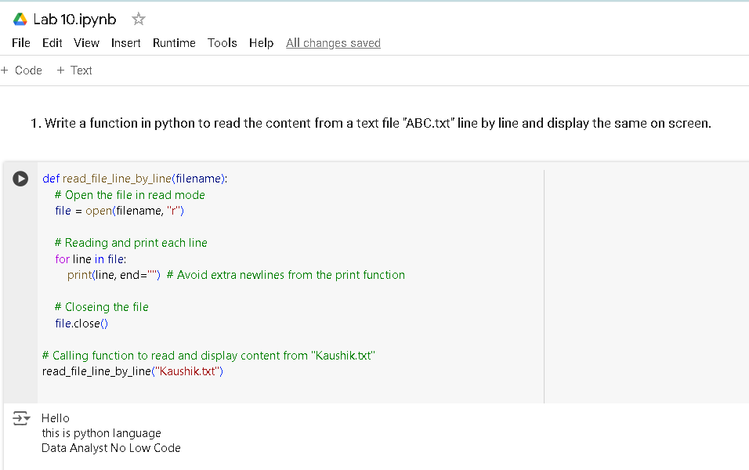Write a function in python to read the content from a text file "ABC.txt" line by line and display the same on screen.
2. Write a function in Python to count and display the total number of words in a text file “ABC.txt”.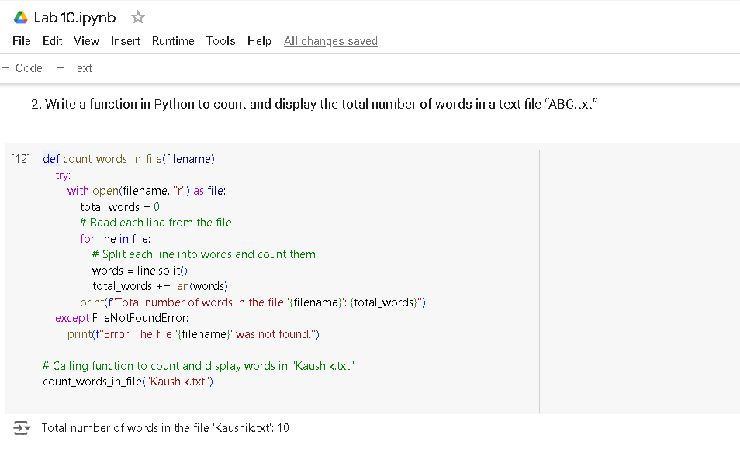
3. 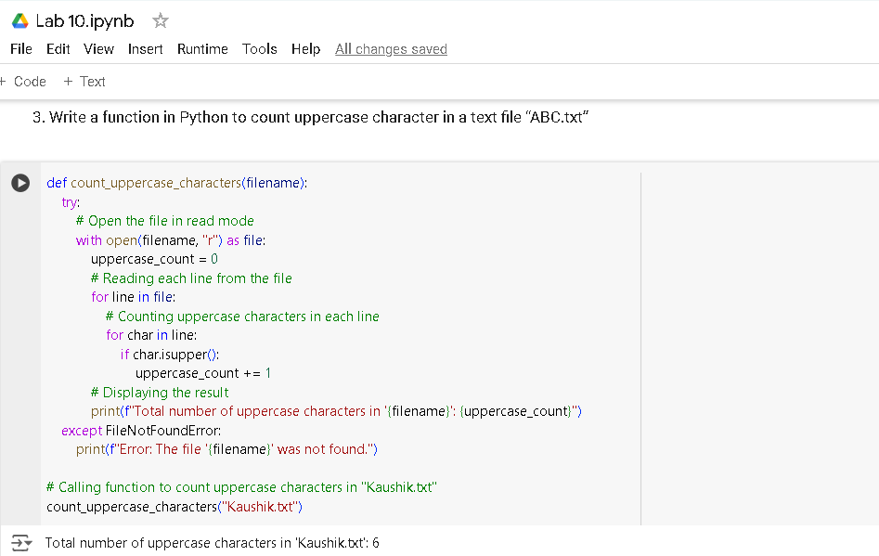Write a function in Python to count uppercase character in a text file “ABC.txt”.
4. Write a function display_words() in python to read lines from a text file "story.txt", and display those words, which are less than 4 characters.

